Name _____________________________________________________________________________

-ed word family

Directions: Choose a bed. Color it appropriately. Write the word for the picture that is on the bed. All words will end with -ed.

1. 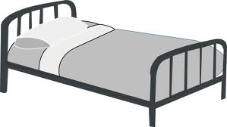 __________________________ 4. __________________________
2.  __________________________ 5.  _________________________
3.  __________________________ 6.  _________________________

Choose 1 –ed word and write a sentence.

__________________________________________________________________________________

__________________________________________________________________________________